1. Project Title: SkillConnect: Freelance Marketplace
2. Project Statement and Outcomes:
- The SkillConnect project aims to develop a web platform that connects freelancers with recruiters by allowing recruiters to post job listings and freelancers to apply for jobs. The platform will enable recruiters to specify job details such as title, required skills, pay per hour, and experience level, while job seekers will create profiles detailing their education, experience, skills, and tech stack.Recruiters will have the ability to review applications submitted by freelancers and accept candidates based on their suitability. Communication between recruiters and job seekers will take place via email notifications to streamline the hiring process.
- The outcome will be a user-friendly and efficient platform that simplifies the recruitment process for companies and provides freelancers with more opportunities. The project will include job posting, profile creation, application tracking, and notification system functionalities.

3. Modules to be Implemented:
- User Authentication & Profile Setup Module
- Job Posting & Application System Module
- Recruiter Dashboard & Notification System Module
- Testing, Review, and Documentation
4. Week-wise Module Implementation and High-Level Requirements:
Weeks 1-2:User Authentication & Profile Setup Module
- Implement recruiter and freelancer login/registration system
- Develop freelancer profile creation with fields for education, experience, tech stack, skills, etc.
- Ensure secure authentication and basic validation checks

Weeks 3-4: Job Posting & Application System Module
- Allow recruiters to post jobs with details like pay per hour, title, tech stack, and requirements
- Enable freelancers to browse jobs and apply by clicking "I'm Interested"
- Create a job application tracking system

Weeks 5-6: Recruiter Dashboard & Notification System Module
- Develop a dashboard for recruiters to view freelancer applications
- Implement job acceptance/rejection functionality
- Integrate email notifications for job updates

Weeks 7-8: Testing, Review, and Documentation
- Conduct a thorough review of the entire system, including functionality, security, and user interface.
- Address any identified bugs or issues and perform necessary fixes.
- Prepare comprehensive documentation & presentation covering system architecture, user guides, and technical specification

5. Flow Chart :
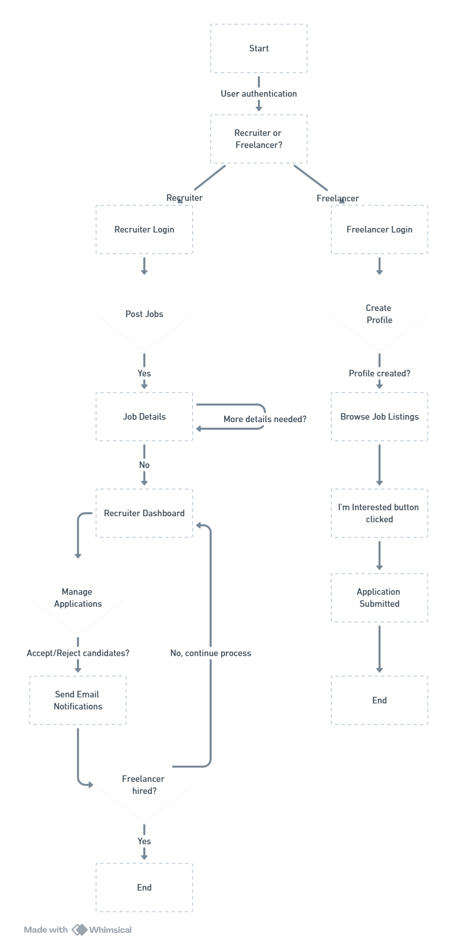
6. Sample output:
